**Lab Session**

The lab project aims to solve the following problems. These problems will help you to apply logic in front-end development.

1. Create a vertical bar graph with the help of animation.
   1. when the page is opened/refreshed, the bar should move from bottom to top, to a predefined percentage. Mention the percentage name below. Create 3 such graphs with 30%, 40% and 80%.
   2. Below percentage print h1 with text “Bar Plot”
   3. Position it in the center of the page.

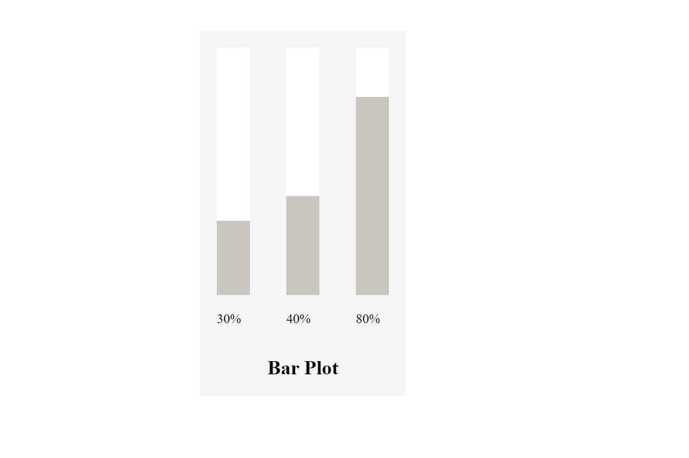

**Learning Objectives:**

1. Apply the concepts learnt to develop the web pages.
2. Be as creative as possible.
3. Have a good understanding of the concepts.